Contestant number: Delivery time: Number of points for a comprehensive project:

Theoretical part – set of electronics questions

(30 points)
Work out an answer to each question. You will receive 1 point for each correct answer.
For tasks that require calculations, use the space within the questions or the back of the test. Clearly number each task. Each result must also include the correct units. A numerical result without units or a sufficiently detailed calculation (or a justified result) will not be accepted!

- Calculate the period of a sinusoidal signal with frequency f = 400.788 871 MHz

t =
- What is the value of the internal resistance of a suitable voltage source?

- Calculate the absolute value of the impedance of a capacitor of capacitance C = 1 mF at a frequency f = 50 Hz.

Z =
- Calculate the resistance value between terminals A-B.

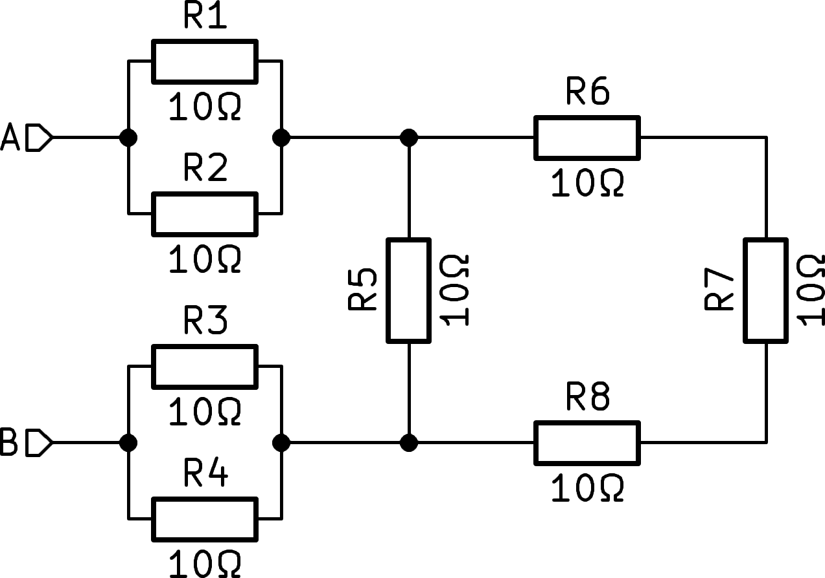

RAB =

- The figure shows the frequency response of a passive circuit – a two-port circuit. The solid line is
amplitude, interrupted phase. Based on the characteristics, determine what kind of circuit it is and draw its diagram. Exact component values are not necessary.

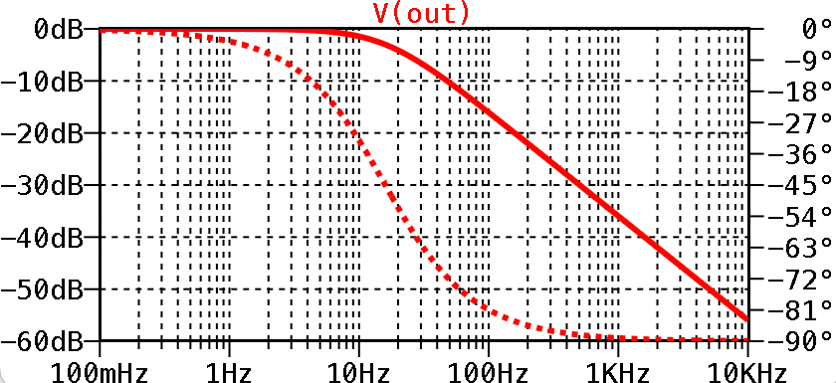

- We have two coaxial cables, the first has an electrical length (delay) ′″1 = 4 ns, the second has an electrical length ′″2 = 10 ns. Both cables are terminated with BNC connectors. We connect both cables in series. What will be the resulting electrical length of the series combination?

τ =
- One of the ways to produce aluminum is electrolysis from alumina. The process is extremely energy-intensive and requires a direct current of I = 300 kA. The furnaces where the process takes place are located d = 100 m from the power source. Calculate the total resistance of the supply wires so that




Theoretical part, category B Page 1 of 4


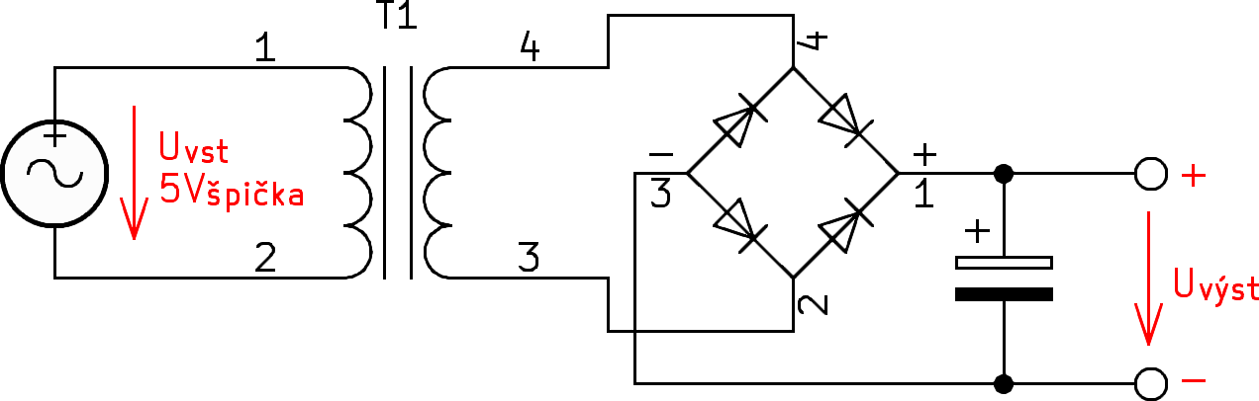
voltage to voltage, the capacitor is charged to voltage.

n2 =
13. Draw a diagram of an AC-coupled amplifier in a common-emitter configuration. Indicate the shape and polarity of the input and output signals.

14. An operational amplifier is a basic building block of electronic circuits. List at least three properties of an ideal operational amplifier.

15. Draw the circuit of an operational amplifier with gain A = +2

16. The attenuator has an attenuation of 20 dB. How many times will the input voltage be attenuat
17. What does it mean if a relay is "latching"?

Page 2 of 4
in which during operation it did not release more than 500 kW of heat loss

Rmaximal =

- The wires from the previous question are made of aluminum (we are in an aluminum factory...). What is the minimum cross-section of these wires? The resistivity of aluminum is r = 2.8x10⁻⁸ Ο.m. (don't forget that we need two wires from the +/- source)

Aminimal =

- Calculate the amount of energy stored in the magnetic field of a coil with inductance L = 1 mH if a current of I = 100 mA flows through it.

W =
- The Thévenin theorem is often used in the analysis of electrical circuits. The so-called Thévenin equivalent circuit is created. What does it sound like? Briefly explain the principle.

- An AC/DC power supply is connected to an AC network with a voltage of UVST = 230 V~, using a complex power meter we measured the consumed current IVST = 1.15 A~, which means <π = 0.8. On the output side, the source supplies UVST = 12 V= and IVÝST = 15 A= to the load. Calculate the efficiency of this source.

ľλ =

- In the device we need to create a galvanically isolated power supply for the measuring part. We use a DC-DC converter and a transformer. Consider the primary voltage Uvst = Všpička (10 Všpička-špička). The number of primary turns is n1 = 5. We require a rectified unstabilized output voltage of at least Uvýst = 7 V, maximum 8 V. At operating current, the voltage on the diode-to-substrate will be UD = 0.65 V, the capacitor has a high capacitance, we neglect the ripple on the output. What will be the number of turns of the secondary n2 to achieve the output voltage targets? Hint: draw your losses

Theoretical part, category B

- What does the parameter/property C0G, NP0, X7R, Y5V mean in ceramic capacitors?

- What is the main difference in the way N-MOSFET and NPN transistors are controlled?

The picture shows a very popular DC-DC voltage converter connection, which is used in switching power supplies. The supply voltage of the circuit is 16 V and the operating voltage of the transistor has an alternating current of D=25% (25% of the time the transistor is fully on, 75% completely off)

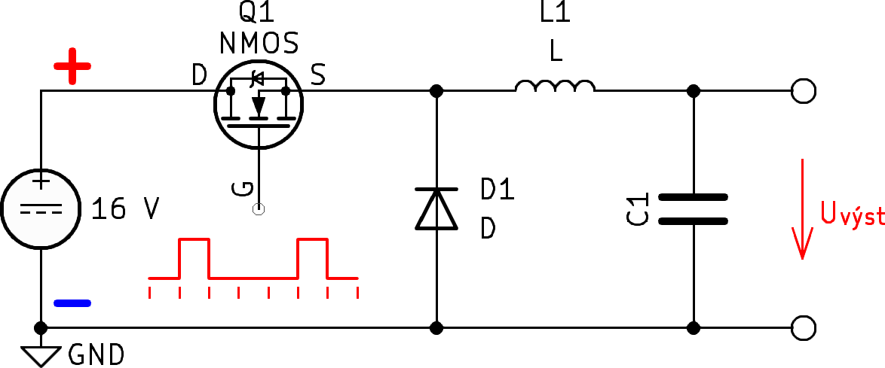

- What is this converter called?

- Mark the output voltage polarities in the diagram. What is the output voltage value?
Uvýst =

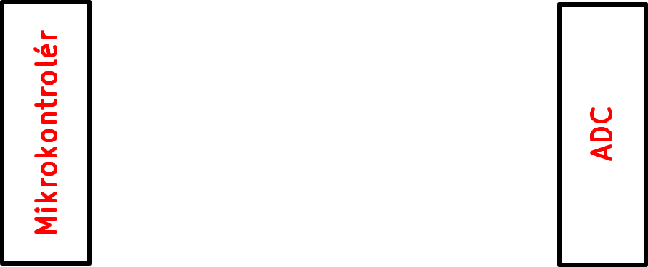
- When communicating with digital peripherals, the so-called SPI bus is very often used. On the left is the control device (microcontroller), on the right is the slave device (AD converter). Draw all the necessary signals for bidirectional communication, write their names and very briefly describe their function

- Write the truth table of a three-stage NAND gate

A | B | C | Y

- 7-segment display driver converts a 4-bit input code into 7 outputs for each segment. The logic function for segment a is as follows:
𝒂 = 𝑨 + 𝑪 + 𝑩 𝑫 + 𝑩) 𝑫)
zrealizujte ju pomocou hradiel

- We are designing a digital measuring instrument that has a voltage measurement with a resolution of at least 0.01%. What is the minimum number of bits of the analog-to-digital converter used? (consider an ideal converter and subsequent sampling, without using digital signal processing techniques)

n =
- Draw a replacement diagram of a real blood vessel, listing all parasitic features/elements you can think of.

Theoretical part, category B Page 3 of 4

- In a precision measuring instrument, we need to set the voltage value at terminal C. The first student looked at the diagram and drew a trimmer there

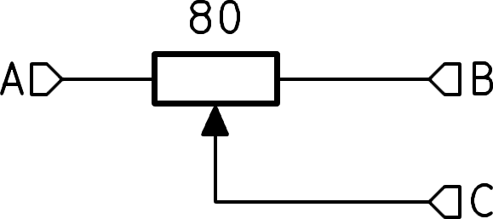
But his colleague tells him that this is not optimal and to design fixed resistors and shorting jumpers:
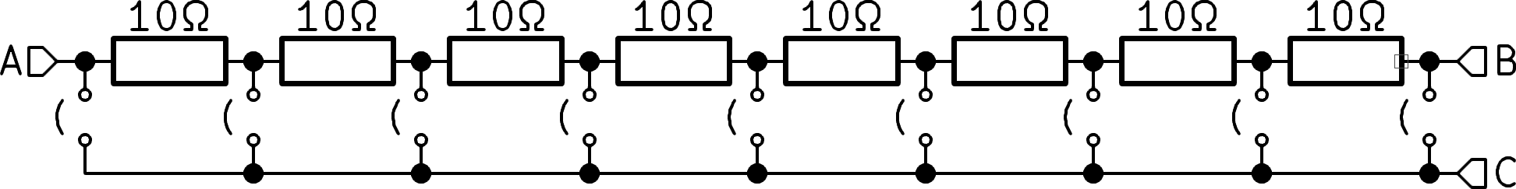
Each of the resistors used is of high quality and costs approx. 10 times as much as the previous trimmer... What important properties for the measuring instrument does the second connection have? Why did he finally use the second design even though it is significantly more expensive? Discuss.

- Koloman measures the volt-ampere characteristic of a 1N4007 rectifier diode. The diode is connected to a current source and the voltage drop is measured. 0.1 mA, 1 mA, 10 mA, 100 mA are applied successively. The voltage drop increases with increasing current, exactly as I expect. He plots the points on a graph. At the last point of 1 A, the reading is unstable, the tunnel drops sharply. Explain why.

- From a reference voltage of 10 V we need to create exactly half, 5 V. The maximum tolerance of the output voltage is 30 mV. We will use a resistor divider with two resistors of the same value of 10 kOhm and a tolerance of 1%. What is the maximum deviation of the output voltage with the worst possible combination of tolerances?
ΔV =
- The most common way to measure with an oscilloscope is to plot time on the x-axis and voltage on the y-axis. In some cases, however, voltage from two different sources is plotted on both the x- and y-axis. This produces a picture similar to the following:

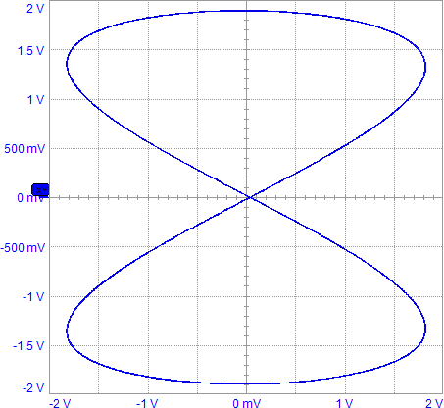

What is this display mode called?

What is it used for?

Will the next 1% resistors be enough, or is it necessary to buy better ones? The standard tolerances available are 5%-2%-1%-0.5%-0.2%-0.1%?

tol.
Theoretical part, category B Page 4 of 4

