Competition task 3:
Creating an application for detecting and locating colored objects
Task Objective: Create a Python application with a user interface that detects and locates objects of specific colors from images provided with the task. The program should use OpenCV, PIL, numpy, tkinter/customtkinter, or other libraries.
The files provided with the task are saved in jpg and png formats.
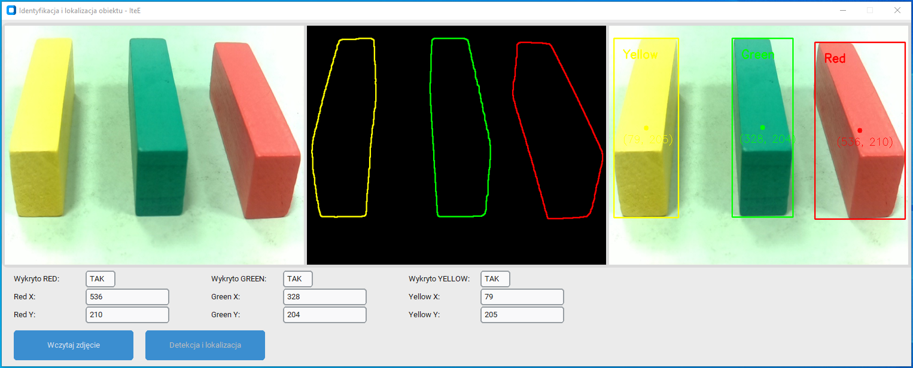
Fig. 1. Sample Python application
Task content:
- Color Detection: Create a program that can detect objects with colors defined in the HSV range. The task is to detect the colors yellow, green, and red.
- Object localization: The program should not only detect colors, but also locate objects by indicating their positions in the image.
- User Interface: Design a simple yet functional user interface using tkinter/customtkinter that allows you to load images, display the processed image and the detection results.
- Documentation: Participant should provide documentation of their code, explaining the key elements and operation of the program.
Evaluation criteria:
- Performance accuracy: Accuracy of color detection and object location.
- Code quality: Cleanliness, organization, and documentation of the source code.
- Interface functionality: Intuitiveness, usability and aesthetics of the user interface.
- Innovation: Creative approach to the problem and possible additional features that distinguish the project.
Additional guidelines:
- The program should be written in Python and use the listed libraries.
- The code should be readable and well commented.
- The evaluation will take into account both the technical aspects of the solution and its practical usability.

