Task: Selecting settings for the PID controller

Objective of the task:
Create a Python tool with an intuitive graphical interface that allows the user to efficiently select PID controller settings for a variety of second-order control objects.

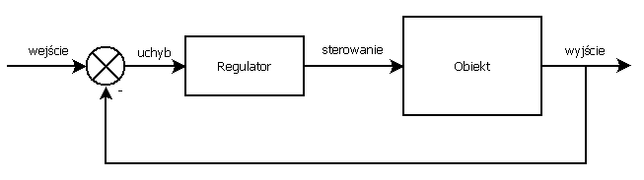
Fig. 1. Block diagram showing the control loop.

Task content:
Your task is to create a Python application that will allow the user to automatically determine optimal PID controller parameters using the Ziegler- Nichols method , with a focus on selecting settings that ensure oscillation-free process control. The tool should also allow the user to manually modify parameters. The application should support data entry for second-order control objects and present the system's response to changes in real time using graphs. The user interface should be intuitive, include functionalities for parameter entry, a PID settings selection panel, and visualization of the control process in graphs. The tool development process allows for the use of libraries such as numpy , scipy.optimize , control , and matplotlib , as well as others the developer deems useful for simulating controller operation and visualizing results.
Below is an example second-order control object:

$$G\left(s\right)=\frac{1}{\left(s+1\right)\left(s+2\right)}$$

Evaluation criteria:

- The program works as described in the task description : it can select settings using the Ziegler- Nichols method and allows manual entry of PID controller settings.
- User Interface Intuitiveness: Assessing whether the interface is easy to use and intuitive, with emphasis on clarity of layout, accessibility of features, and visual aesthetics.
- Visualization Quality: Assessment of whether charts and other graphic elements are legible, aesthetically pleasing, and provide useful information about the regulatory status.
- Code Readability and Organization: Is the code easy to understand, well commented, and organized?

