

2024

MECHATRONICS
CzechSkills 2024
Test Project

FESTO Mechatronics Competition – your ticket to the Mechatronics CzechSkills 2024 finals!


National coordinator


Expert guarantor

Contents
2
I. Test project 3
Module A 3
Module B 3
Module C 4



Test project

Module A

Assemble the production line with the conveyor belt mechanically according to the documentation in the appendix. Do not deal with the electrical wiring in this part of the task.

Your task is complete when:
- The station is mechanically assembled correctly.

The time allowed for this task is 180 minutes.
The system will be evaluated after the first round of the competition. Hardware issues from this part of the task can be resolved in the next round of the competition.

Evaluation criteria:
Complete assembly = 100 points

Module B

Connect the production line with the conveyor belt. Documentation for connecting the production line can be found in the appendix.
- Optional connectors: -X3, -X4, -XG1, -XG2, -WG1, -WG2

Your task is complete when:
- The station is correctly connected.
- The function of individual digital inputs and outputs has been tested.

The time limit for this task is 150 minutes.
The system will be evaluated after the second round of the competition. Hardware issues from this part of the task can be resolved in the next round of the competition.

Evaluation criteria:
Functional electrical connection without optional connectors = 80% = 80 points
Functional electrical connection with optional connectors = 100% = 100 points

Module C

Design and commission a circuit for controlling the production line according to the requirements described below. The line is controlled by three buttons (START, STOP and RESET) and one switch (STATUS). The line operates as follows:
- I place the workpiece in the middle of the conveyor belt. Then I press the START button to start the belt running in the right direction. Whenever the workpiece reaches the end position, the line reverses direction and the process repeats continuously.
- I can stop the process at any time by pressing the STOP button, and I must press START again to restart the line according to point 1.
- The STATUS switch is used to select the speed of the conveyor belt (slow/fast).
- The line may encounter an error during operation. This occurs when the line's running time in any direction is exceeded (e.g. someone removes a workpiece or it falls off the conveyor belt without being detected by the sensor). This means that if the direction is not changed within the specified time (fast mode = 6 s, slow mode = 11 s), the system stops and the LED indicator lights up. Restarting is only possible after pressing RESET and then START.
Control this line using the FluidSIM programme. Here you can design the line control and then connect the computer to the I/O device via Easyport.

Procedure for setting up Easyport in FluidSIM:
- In the library, select these marked items in the Easyport/OPC/DDE tab.
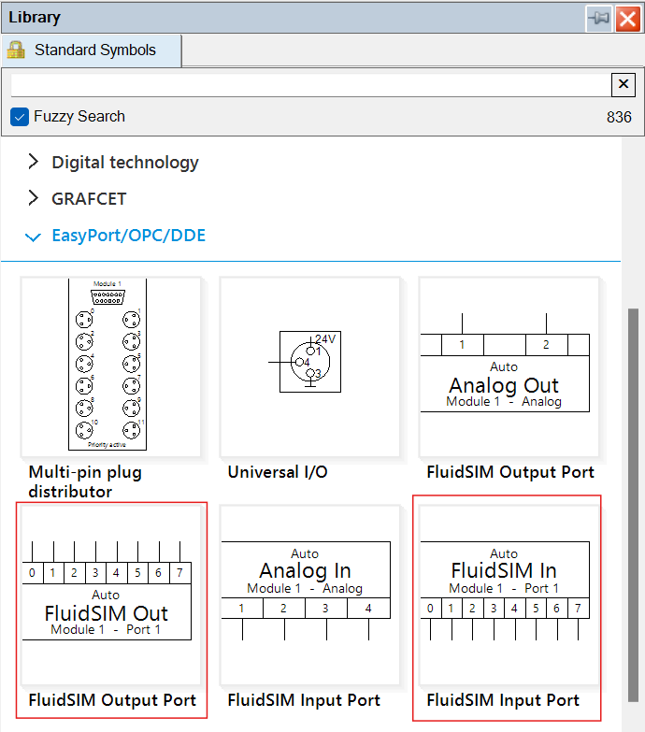
- Configure both modules as shown in the following figure and press Detect EasyPorts after connecting EasyPort to your PC.
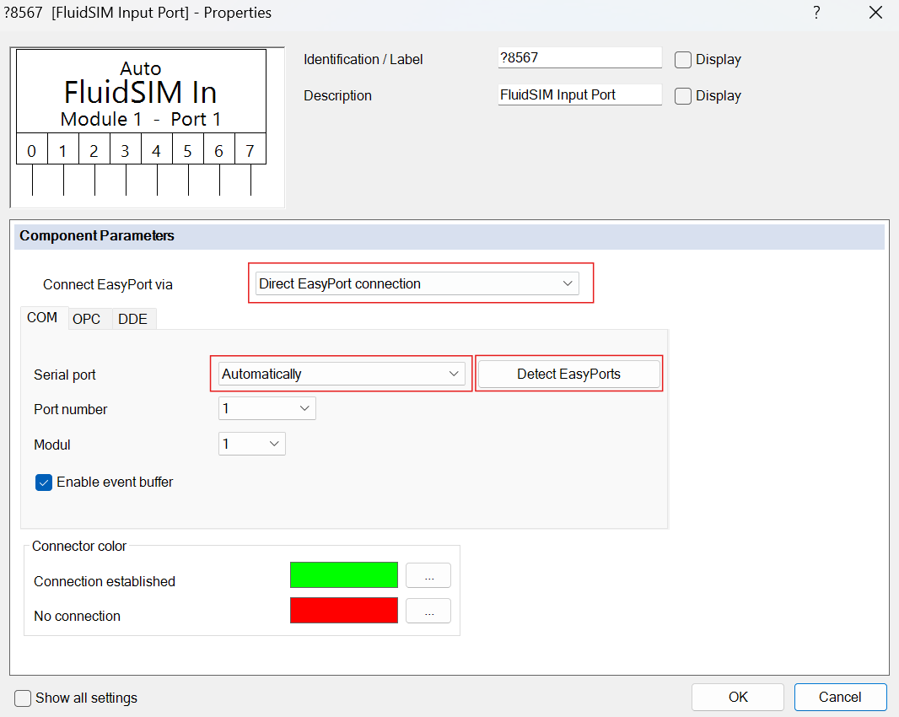

- After this step, EasyPort should connect to FluidSIM.
Your task is complete when:
- The station is correctly connected and operational.
- The programme described above is running on the station.

The time limit for completing this task is 180 minutes.

The system will be evaluated after this round of the competition. Hardware and software issues cannot be corrected after submission or after the competition time has ended.

Evaluation criteria:
Complete and correct functioning of the programme = 100% = 100 points.

Required materials:
PC connection > Skillsconveyor
PC with Fluidsim and drivers installed

Design an elevator control system for your customer (see the image below). The elevator serves three floors (0, 1, 2). On the middle floor (1), there are Up and Down buttons. On the ground floor (0), there is only an Up button, and on the top floor (2), there is only a Down button. There are 0, 1, and 2 buttons in the lift cabin. The lift must not start moving if the doors are open. Upon arrival at a floor, the lift must open the doors, close them after a certain period of time, and only then can it continue.

Select the difficulty level below and whether you want to solve the problem.

Design an elevator control system for your customer (see the image below). The elevator serves three floors (0, 1, 2). On the middle floor (1), there are Up and Down buttons. On the ground floor (0), there is only an Up button, and on the top floor (2), there is only a Down button. There are buttons 0, 1, and 2 in the lift cabin. The lift must not start moving if the doors are open. Upon arrival at a floor, the lift must open the doors, close them after a certain time, and only then can it continue.

Select the difficulty level below and whether you want to solve the puzzle.

Difficulty level
1. Level
- Make the lift work so that it can travel from any floor A to any floor B. You do not need to solve whether the Up or Down button is selected on the middle floor. You do not need to solve the problem of stopping at intermediate floors (e.g. when travelling from the 2nd floor to the 0th floor, it does not respond to the button being pressed on the 1st floor).
Requirements:
- The lift must not start moving until the doors are closed.
- After reaching the destination floor, it opens the doors, closes them after a certain time, and waits for the next request.
- Requests can be made from both the cabin and the floors.

2. Level
- Put the lift into operation as a fully-fledged system. If the lift is travelling from the 2nd floor to the 0th floor and the Down button is pressed on the 1st floor, the lift must stop on the 1st floor, open the doors and, after they close, continue to the 0th floor. The same applies in the opposite direction.
- If the Down button is pressed on the 1st floor, the lift must continue downwards and must not be redirected upwards by another request.
Requirements:
- The lift must respect the direction buttons on the floors.
- When travelling upwards, it only serves requests to go upwards; when travelling downwards, it only serves requests to go downwards.
- After completing the journey in a given direction, it may change direction and serve other requests.

Note
- Submitted solutions without a selected difficulty level will not be evaluated.
Select relay logic for the solution.
- Additional task for level 2:
- Design an electric drive of the electric cylinder type with a stepper motor for moving a 5 kg product to a camera inspection station. One movement must be 0.01 m, i.e. performed in 1 s. The required movement length is 300 mm. The direction of movement is horizontal (0°).
- Perform the calculation using the Electric Motion Sizing calculation software (available from Festo.cz).
www.festo.com
  - Perform basic settings in the FAS programme (again freely to download at
%3B8143167%3B8143168%3B5111189&productName=Ovlada%C4%8De+servopohon%C5%AF&groupId
=4&documentId=648077&documentTypeGroup=SOFTWARE).

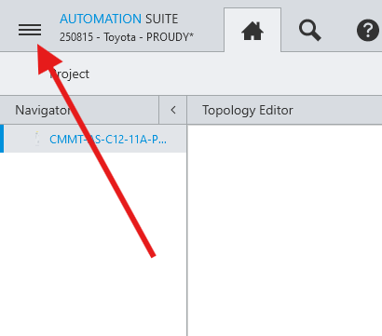
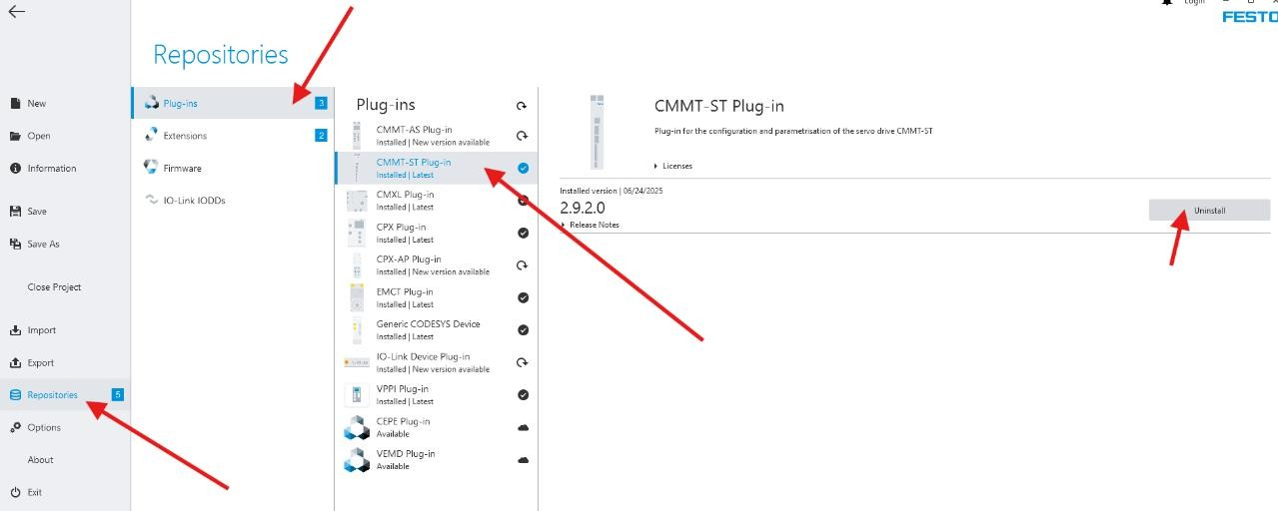

Requirements:
  - Send the result in the format shown in the image:
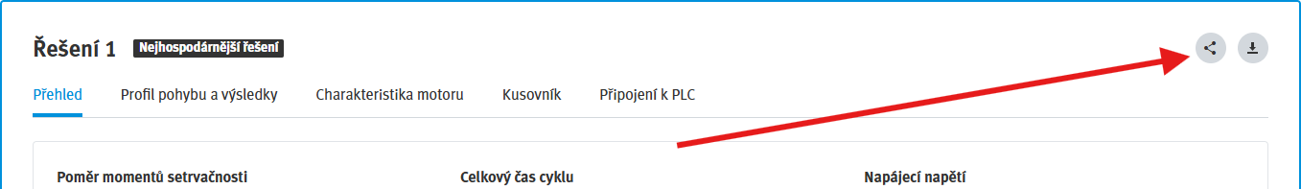

  - Send the project export from the FAS programme.
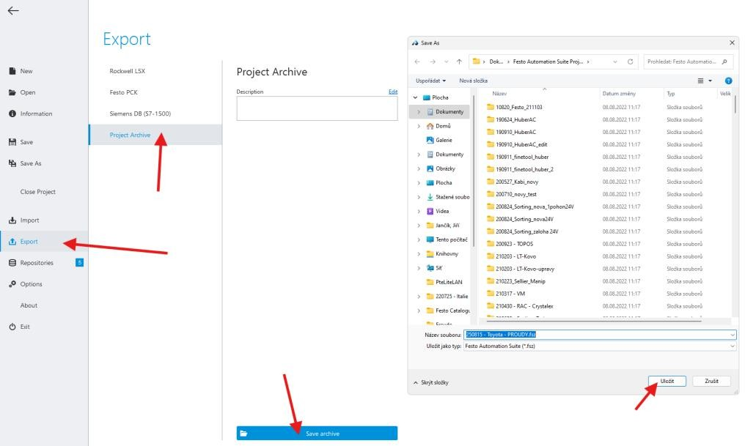

Example of solution difficulty selection:

Selected: Level 2  Maximum possible score:  - 20% Time of receipt: How quickly the solution was submitted.  - 30% Documentation: Quality and completeness of documentation.  50% Correctly solved selected difficulty:  - Level 2 (50%)  Total maximum 100%. | Selected: Level 1  Maximum possible score:  - 20% Time of receipt: How quickly the solution was submitted.  - 30% Documentation: Quality and completeness of documentation.  - 25% Correctly solved selected difficulty:  - Level 1 (25%)  Maximum total of 100%.

Select the following modules from the library:
Component Library -> Virtual Systems -> Electrical Installation -> Elevator

