

Competitons rules
Slovak Skills - Young Mechatronics

1. General Provisions
Type of competition: Knowledge and practical competition in the field of Mechatronics
Categories: Competition of 2-member teams
Place: STU Bratislava with headquarters in Trnava, Faculty of Materials Science and Technology, Institute of Applied Informatics, Automation and Mechatronics
Date: 23. to 24. 4. 2024
Organizer: FESTO spol. s r. o., ŠIOV
Competition Director: Tomáš Horák
Members of the evaluation committee: Chairman: Ing. Milan Daňo
Expert guarantor: doc. Ing. Michal Kopček, PhD.
joined the position. Juror: doc. Ing. Martin Juhás, PhD.
joined the position. Juror: Ing. Martin Bartoň, PhD.
II. Technical provisions
Competition conditions:
Teams will enter the competition according to the schedule. Before starting the tasks, they will choose whether they want to compete in Slovak or in English. The choice of completing the task in English is additionally advantageous in terms of points. According to the task assignment, the team will work out all the organs that will be needed for the given task. Individual parts of the tasks are scored. Participants work only in the designated area. They must report any leaving of the area in advance to the supervisor. During the competition, it is prohibited to use mobile phones and other electronic devices that are not directly necessary for solving the tasks.
The time limit for completing the entire task is 120 minutes. The first 10 minutes. they can consult the solution with their companion. The consultation is only verbal, i.e. it is not allowed to use a computer, writing utensils, or any mechanical components.
After completing the task, the team will present its solution to the evaluation committee in the chosen language. The committee will then evaluate the given solution.
Evaluation:
The maximum number of points that a team can get for the technical part is 100. During the technical evaluation there is also the so-called Professional Practice (rules for the selection of assembly of accessory components). The rules for Professional Practice can be found as an appendix to the competition propositions. In the case of solving the choice in English, the additional value of points is a maximum of 10, while the evaluation committee will award the value of points from 0 to 10 according to the level of English language proficiency of the competing team. The team with the highest number of points becomes the winner.
Equipment for solving the task:
All components (except tools) necessary for solving the task such as drives, sensors, valves, PLC (SIEMENS S7), PC, etc. will be provided by the organizer.
Participants' own tools and accessories:
The team will bring their own tools in the minimum composition: a set of hexagonal keys (hexagon), a set of open-end wrenches, a set of electrician's screwdrivers, tools for stripping thicker and thinner insulation from conductors (stripping pliers), crimping pliers for end sleeves and small wire cutters.
The competition team can provide its own PLC and PC for its programming. One PLC is required for each station. The competition will take place at two stations (two PLCs are required). Each own PLC must be connectable to the station using two SYSLINK connectors and must have at least 16 digital inputs and 16 digital outputs (8 inputs and 8 outputs per connector). The entire station is also powered by 24VDC via the SYSLINK connection! The competition team is responsible for the correct connection of inputs, outputs and between the own PLC and the station (SYSLINK connector). Any malfunction of the own PLC connection will be assessed as an error in solving the task and no corrections apply to it! The SYSLINK connector connection is on the last page.
All necessary to master the task:
basic properties of pneumatic drives basic properties of pneumatic and electropneumatic valves valve batteries, design, function, connection vacuum, its properties, production and distribution end position sensors, function, adjustment, signal processing vacuum sensors, design, connection, signal processing optical sensors, design, connection, signal processing PLC programming and configuration (S7)
logical functions and their solution in the program electrical engineering (24 V DC circuits)

Program – Timetable:
The competition will take place according to the program compiled by ŠIOV.
IV. Final Provisions
The organizers reserve the right to change the proposals if the current situation requires it.
Connecting SYSLINK connectors
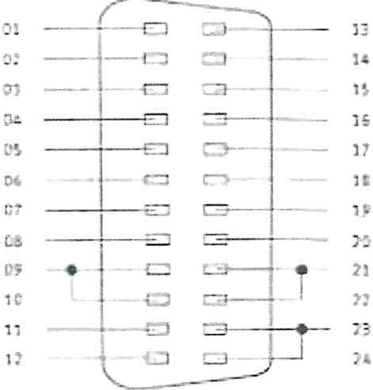

PIN | PLC signal
1 | Output O
2 | Output 1
3 | Output 2
4 | Output 3
s | Output 4
6 | Output S
7 | Output 6
8 | Output 7
9 | + 24 VOC
10 | + 24 VOC
11 | ovoc
12 | ovoc
13 | Entry O
4 | Entry 1
15 | Entry 2
16 | Entry 3
17 | Entry 4
18 | Entry S
19 | Entry 6
20 | Entry 7
21 | + 24 VOC
22 | + 24 VOC
23 | ovoc
24 | ovoc

