Competitions rules mechatronics



**Skills Slovakia**

1. **General rules**

Type of competition: Knowledge and practical competition in the field of Mechatronics

The competition is open to all vocational secondary schools that teach vocational subjects such as: Mechatronics, Mechanics, Mechanical Engineering, Mechanical Engineering, Automation, Electrical and Electronic Engineering...

Category: 2-member team competition

**Main shot of the Mechatronics competition**:

Solve complex problems, understanding of tasks, expertise.

Repair components and equipment as well as correct perception of machine mechanics.

Use PLCs and computers as well as handle basic electrical wiring.

Use tools and handle mechanical design work.

Work in a team, proper distribution of tasks due to time constraints.

Competition and comparison of knowledge of secondary vocational schools in Slovakia.

**Competition category**:

The competition consists of 2-member teams for Secondary Vocational Schools and Secondary Industrial Schools not

only in the field of Mechatronics but also Mechanical Engineer, Automation Engineer, Electrical Engineer as well as

Mechanics.

Location: STU Bratislava with headquarters in Trnava, Faculty of Materials Science and Technology, Institute of Applied Informatics, Auation and Mechatronics

Date: **27th to 28th March 2025**

Organizer: **FESTO spol. s r. o., State Institute of Vocational Education**

Competition Director: Tomáš Horák

**The members of the evaluation committee shall consist of a minimum of 3 members (jurors):**

Chairman of the evaluation committee: a representative of Festo as the global expert guarantor of the Mechatronics

Competition Vice-chair of the evaluation committee: a representative from the academic sphere (STU University, TUKE,)

for the study programmes Automation, Informatics or Mechatronics Second vice-chair of the evaluation committee: a

representative from industry (expert in automation, mechanics, mechanical engineering, electrical engineering,)

*The evaluation of the competitors is in a separate document as "Competition criteria" and "Evaluation “.

Members of the evaluation committee:

Chairman: Ing. Milan Daňo,

Expert guarantor: doc. Ing. Michal Kopček, PhD.

Joined the position. Juror: doc. Ing. Martin Juhás, PhD.

Joined the position. Juror: Ing. Martin Bartoň, PhD.

1. **Technical Provisions and Competition Rules**

**Competition conditions:**

* + Teams will enter the competition according to the schedule. Before the start of the tasks, the competitors will choose whether they want to complete the competition in Slovak or English. The choice of completing the competition in English is additionally scored.
  + The team will work out all the points that will be defined for the task according to the task. The individual parts of the tasks are scored. Participants work only in the defined space. They must report in advance to the supervisor (committee) if they leave the area. The use of mobile phones and other electronic devices that are not directly necessary for solving the tasks is forbidden during the competition.
  + The time limit for completing the whole assignment is 120 min. For the first 10 min teams can consult the solution with their accompaniment (teacher, coach, lecturer). The consultation is verbal only, i.e., no computer, writing utensils or any mechanical components are allowed.
  + After the completion of the task, the team will present their solution to the evaluation committee in their chosen language. The committee will then evaluate the solution according to the predetermined evaluation criteria.
  + Competitors must place the station within their space (2.5 m x 4 m) so that it is as visible as possible to visitors.
  + As all workstations face the shorter side of the visitors, you must arrange your space so that the MPS system is in the half of the workstation that faces the visitors from the front. Conditions: 1 table, 1 desk and 2 chairs must remain in the background
  + For the workplaces, electricity and air will come from the visitors.
  + Ensure that the 1 m space between visitors and the workplace is not a handy store. This
  + Space must remain free!
  + Example

Obrázok, na ktorom je text, snímka obrazovky, rad, diagram

Obsah vygenerovaný pomocou AI môže byť nesprávny.

* + Make sure that competitors only receive a form with a score summary for each problem, not individual marks for each solution.
  + Before arriving at the actual competition, read, study and print out the HSE document (HMI/PP Judgment internationally).
  + Competitors must wear normal work clothes (shorts are not allowed) - at all times during the competition, also safety shoes are a regulation - at all times during the competition.
  + Also, safety goggles - while working on the system right after setting up the pneumatic connection.

**Rating:**

The maximum number of points a team can receive for the technical part is 100. Part of the technical evaluation is also the so-called Professional Practice (rules for the correct assembly of components and accessories). The rules for the Professional Practice can be found as an appendix to the competition regulations. In the case of the choice of the English language solution, the additional point value is a maximum of 10, and the evaluation committee will award a point value from 0 to 10 according to the English language proficiency level of the competing team. The team with the highest number of points is the winner.

Scorecard:

School /Competition Team: Elaboration time:

|  |  |  |  |
| --- | --- | --- | --- |
| Criterion | Sub-criterion | Max. of points | Max. number of points |
|  | | | |
| Design - proposal | Layout of elements on the MPS station | 10 |  |
| Correct assembly of components | 10 |  |
|  |  |  |
|  | | | |
| Function | Manual mode | 25 |  |
| AUTO mode | 30 |  |
| Correct workpiece distribution | 10 |  |
|  | | | |
| Professional Practice | Pneumatic/Electropneumatic | 3 |  |
| Electrics | 3 |  |
| Mechanics | 3 |  |
| Other | 3 |  |
| Overall impression | 3 |  |

**Jury´s signature:**

**...................................**

**Equipment for solving the problem:**

All components (except tools) required for the task such as actuators sensors, valves, PLC (SIEMENS S7 300), PC etc. will be supplied by the organizer.

Participants' own tools and accessories:

Each team will bring their own tools with a minimum of a set of hex keys, a set of fork wrenches, a set of

electrician's screwdrivers.

The competing team can bring its own PLC and PC needed for its programming. One PLC per station is required. The competition will be run on two stations (two PLCs are required). Each custom PLC must connect to the station using two SYSLINK connectors and must have a minimum of 16 digital inputs and 16 digital outputs (8 inputs and 8 outputs per connector). Through the SYSLINK connection the whole station is also powered by 24VDC! It is the responsibility of the competing team to make sure that the inputs, outputs and power supply are properly connected between their own PLC and the station (SYSLINK connector). Any malfunctioning of the connection of the own PLC will be evaluated as a problem-solving error and no allowances will be applied! The wiring of the SYSLINK connector is on the last page.

**Topics needed to master the task:**

* basic characteristics of pneumatic actuators
* basic characteristics of pneumatic and electro-pneumatic valves
* valve batteries, construction, function, connection
* vacuum, its properties, production and distribution.
* end position sensors, function, adjustment, signal processing
* vacuum sensors, design, wiring, signal processing
* optical sensors, construction, soldering, signal processing
* PLC programming and configuration (S7)
* logical functions and their solution in the program
* Electrical engineering (24 V DC circuits)

1. **Programme - timetable**

The competition will be held according to the programme drawn up by ŠIOV and the co-organisers and technical guarantors Festo spol.s r.o. Slovakia and the Slovak Technical University Faculty of Materials Technology in Trnava, represented by the Institute of Applied Informatics, Automation and Mechatronics.

Preliminary draft programme for the 2-day national competition:

**Day one:**

07:00 - 07:45 Arrival - registration of participants

MTF STU in Trnava, Institute of Applied Informatics, Automation and Mechatronics

08:00 - 08:30 Welcome, speeches - registration of teams, drawing of lots into groups, tour of workplaces, instruction on OSH

**08:30 Start of the competition**

08:30 - 10:30 **Group 1**: 3 teams / other teams tour of UIAM MTF laboratories and

facilities - Working Groups /Workshops

10:30 - 11:00 Group 1 evaluation

11:00 - 13:00 **Group 2**: 3 teams / other teams tour of the UIAM MTF laboratory facilities - Working Groups /Workshops

13:00 - 13:30 Group 2 evaluation

*Lunch - individual*

13:30 - 15:30 **Group 3**: 3 teams / other teams tour of UIAM MTF laboratories and

facilities - Working Groups /Workshops

15:30 - 16:00 Group 3 evaluation

16:00 End of the first day

**The second day**

07:00 - 07:45 Arrival - registration of participants

MTF STU in Trnava, Institute of Applied Informatics, Automation and Mechatronics

**08:00 Start of the 2nd competition day**

08:00 - 10:00 **Group 4**: 3 teams / other teams tour of UIAM MTF laboratories and

facilities - Working Groups /Workshops

|  |  |  |
| --- | --- | --- |
| 10:00 - 10: | 30 Group 4 evaluation |  |
| 10:30 - 12:30 | **Group 5**: 3 teams / other teams tour of the facilities - Working Groups /Workshops | UIAM MTF laboratory |
| 12:30 - 13: | 00 Group 5 evaluation  *Lunch - individual* |  |

13:00 - 15:00 **Group 6**: 3 teams / other teams tour of the UIAM MTF laboratories and

facilities - Working Groups /Workshops

15:00 - 15:30 Evaluation of the 6th group

15:30 - 16:00 Compilation of results

**16:00 Overall evaluation of the competition results - conclusion and award ceremony**

1. **Project Task**

Maximum time: 120 min Max. points: 110

I Basic information’s

School:

Competing students:

**Scenario**

Your task is to build handling systems on MPS stations. The aim of the manipulation is to transfer and sort workpieces from input magazine to 3 output magazines (slides) using pneumatic drives, conveyor and vacuum. Position of the input magazine and drives on the station 1 has to be decided by you. Position of the components on the station 2 is given by the application and it is forbidden to change it! On the station 2 you can only adjust sensors and end positions. Control of both systems has to be made by PLC´s, which has its inputs and outputs connected to the green terminals.

Task is completed when all parts are mounted, all cables and tubes are connected and the manipulation is functional after the described sequence and additional conditions. Sequence Order of the workpieces in the input magazine will be decided by the evaluation committee.

Requirements and connections Initial conditions:

Feeder extracted from the input magazine Swivel arm over conveyor

Ejectors on conveyor retracted

End stop on measuring place extended

START LED on station 1 is flashing with 2Hz (manipulation)

Sequence:

Sequence begins with pressing START button (front panel of MPS station 1) Workpiece pushed out of magazine

Swivel arm turns to magazine Workpiece gripped by vacuum Feeder extracts from magazine

Swivel arm turns over to the conveyor Release the workpiece

Swivel arm turns to magazine Conveyor moves

Distribution of workpiece to the place of identification Identification of workpiece

Identified workpiece moves to the right magazine (slide) After the workpiece slides to the magazine conveyor turns off

1. **Additional condition´s :**

Sequence can be started only when workpiece is present in the input magazine

If the magazine on station 1 is empty lights Q1 and Q2 on its front panel are flashing alternately with 1 Hz System should be operated in 2 modes - MANUAL and AUTO. Mode is set via key on front panel. In position MANUAL machine makes only one cycle. In position AUTO machine makes 4 cycles (4 workpieces moved) By pressing the STOP buttons (not Emergency stop) anytime, the stations must stop immediately Movement of swivel arm with workpiece is possible only if the vacuum level is reached

Order of workpieces in output magazines (magazines are counted from left side when you stand

in front of the station) Slide number 1 – silver workpiece

* + Slide number 2 – red workpiece

Sl ide number 3 – black workpiece

* + After the colour identification and during distribution of workpiece to output magazine, the lights Q1 and Q2 on station number 2 are lighted as follows: Silver workpiece - Q1-ON, Q2-OFF
  + Black workpiece - Q1-OFF, Q2-ON
  + Red workpiece - Q1-ON, Q2-ON
  + When the station 2 is ready to identify a workpiece the lights Q1 and Q2 on its front panel are flashing alternately with 2 Hz
  + The conveyor on station 2 must not move when the swivel arm is over the conveyor
  + Additional information’s:
  + For the communication between the two stations use inputs and outputs on the front panels of the stations. These signals are connected to the PLC together with the signals of START, STOP, RESET etc.
  + On the conveyor of the station 2 there are two sensors (B2, B3) for the colour identification of the workpieces. Sensor B2 identifies silver colour and sensor B3 identifies silver and red colour. If none of these two sensors is activated, the colour of the workpiece is black.
  + Connection of the inputs and outputs on the terminal for station 2:

|  |  |  |  |  |  |  |
| --- | --- | --- | --- | --- | --- | --- |
| * + Input | * + Mark | | * + Description | * + Output | * + Mark | * + Description |
| * + I0 | * + PART_AV | | * + Part available | * + O0 | * + IN | * + Conveyor on |
| * + I1 | * + B2 | | * + Silver colour | * + O1 | * + 1M1 | * + Extend ejector 1 |
| * + I2 | * + B3 | | * + Silver and red colour | * + O2 | * + 2M1 | * + Extend ejector 2 |
| * + I3 | * + B4 | | * + Workpiece in output   + magazine | * + O3 | * + 3M1 | * + Retract stopper on   + conveyor |
| * + I4 | | * + 1B1 | | * + Ejector 1 retracted | | * + O4 |
| * + I5 | | * + 1B2 | | * + Ejector 1 extended | | * + O5 |
| * + I6 | | * + 2B1 | | * + Ejector 2 retracted | | * + O6 |
| * + I7 | | * + 2B2 | | * + Ejector 2 extended | | * + O7 |

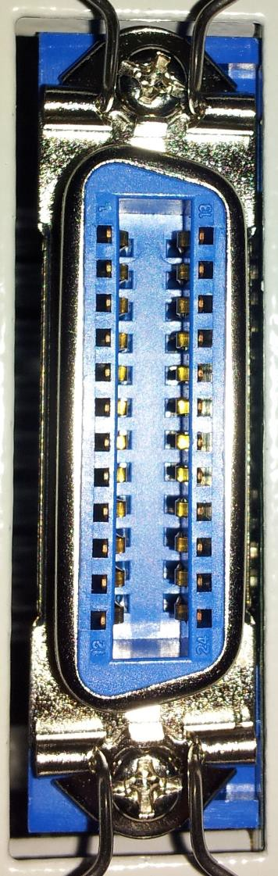

# Connecting the SYSLINK connector.

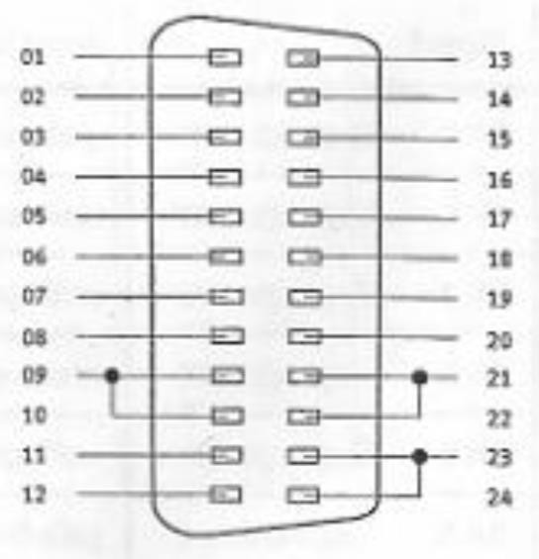

|  |  |
| --- | --- |
| PIN | Signal PLC |
| 1 | Output 0 |
| 2 | Output 1 |
| 3 | Output 2 |
| 4 | Output 3 |
| 5 | Output 4 |
| 6 | Output 5 |
| 7 | Output 6 |
| 8 | Output 7 |
| 9 | + 24 VDC |
| 10 | + 24 VDC |
| 11 | 0 VDC |
| 12 | 0 VDC |
| 13 | Input 0 |
| 14 | Input 1 |
| 15 | Input 2 |
| 16 | Input 3 |
| 17 | Input 4 |
| 18 | Input 5 |
| 19 | Input 6 |
| 20 | Input 7 |
| 21 | + 24 VDC |
| 22 | + 24 VDC |
| 23 | 0 VDC |
| 24 | 0 VDC |

–