Obrázok, na ktorom je text, písmo, grafika, logo

Obsah vygenerovaný pomocou AI môže byť nesprávny.

Contestant number: Delivery time: Number of points for a comprehensive project:

Theoretical part – set of electronics questions

(30 points)

Work out an answer to each question. You will receive 1 point for each correct answer.

***For tasks that require calculations, use the space within the questions or the back of the test. Clearly number each task. Each result must also include the correct units. A numerical result without units or a sufficiently detailed calculation (or a justified result) will not be accepted!***

1. Calculate the period of a sinusoidal signal with frequency f = 400.788 871 MHz

# t =

2. What is the value of the internal resistance of an ideal voltage source?

3. Calculate the value of the complex impedance between terminals A-B. Frequency f = 50 Hz.

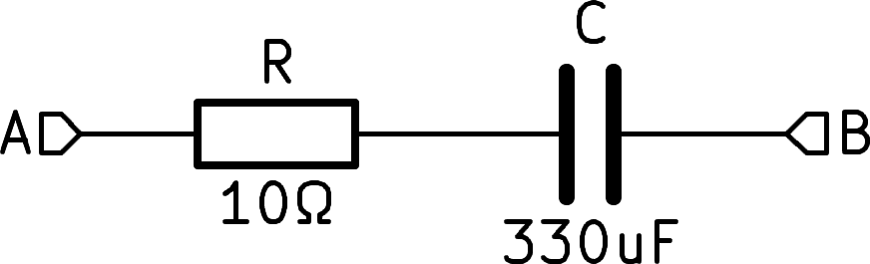

**ZAB =**

4. Calculate the resistance value between terminals A-B.

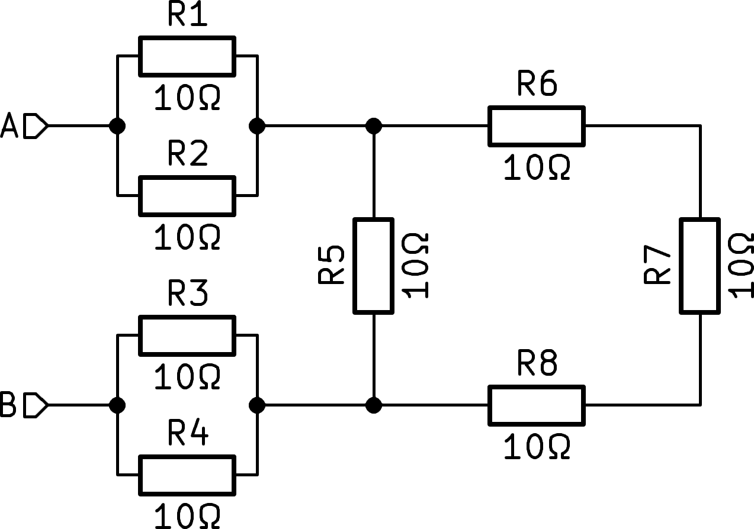

**RAB =**

5. The figure shows the frequency response of a passive circuit – a two-gate. The solid line is the amplitude, the dashed line is the phase. Based on the characteristic, determine what kind of circuit it is and draw its diagram. Exact component values ​​are not necessary.

.

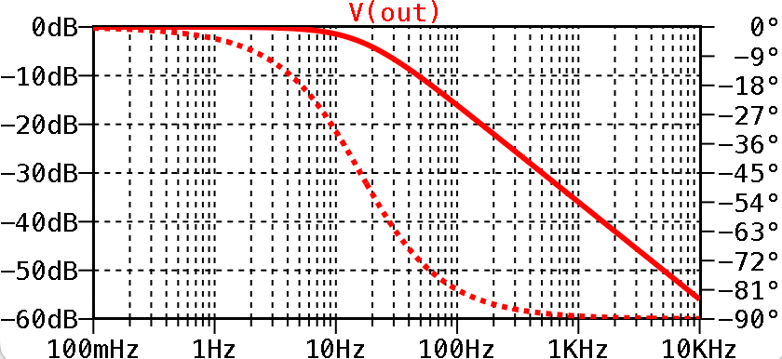

6. We have two coaxial cables, the first has an electrical length (delay) 1 = 4 ns and a characteristic impedance Z1 = 50 Ο, the second has an electrical length 2 = 10 ns and the same characteristic impedance Z2 = 50 Ο. Both cables are terminated with BNC connectors. We connect both cables in series. What will be the resulting electrical length and what will be the resulting characteristic impedance of the series combination?

**** **= Z =**

****Theoretical part, category A



 Page 1 of 4

7. One of the ways to produce aluminum is electrolysis from alumina. The process is extremely energy-intensive and requires a direct current of I = 300 kA. The furnaces where the process takes place are located d = 100 m from the power source. Calculate the total resistance of the supply wires so that no more than 500 kW of heat loss is released during operation.

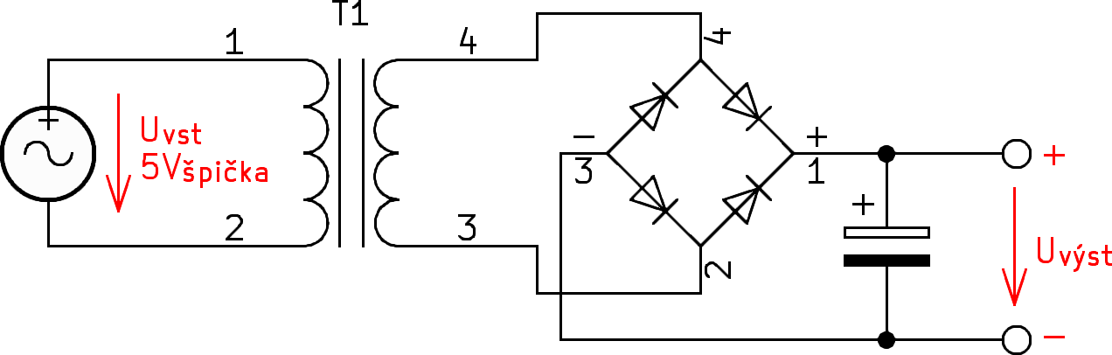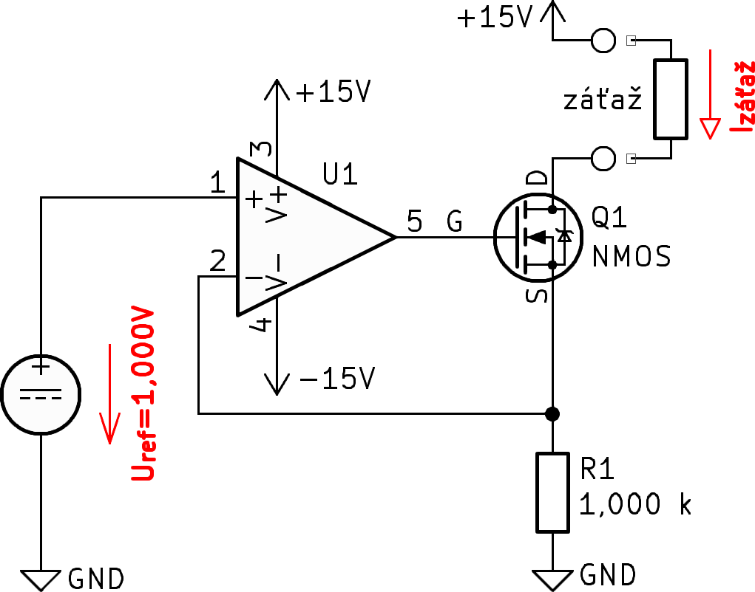

**n2 =**

13. Draw a diagram of an ac-coupled amplifier in a common-emitter circuit. Indicate the shape and polarity of the input and output signals.

14. An operational amplifier is a basic building block of electronic circuits. List at least three properties of an ideal operational amplifier.

15. The picture shows a very popular connection with an operational amplifier

What is its function?

What is the value of the current flowing through the load (assuming it is a resistor with a value of at most 10 kΟ)?

**Iburden=**

Page 2 z 4



**Rmaximal =**

8. The wires from the previous question are made of aluminum (we are in an aluminum factory...). What is the minimum cross-section of these wires? The resistivity of aluminum is r = 2.8x10-8 Ο.m. (don't forget that we need two wires from the +/- source)

**Aminimal =**

9. Calculate the amount of energy stored in the magnetic field of a coil with inductance L = 1 mH if a current of I = 100 mA flows through it.

# W =

10. The Thévenin theorem is often used in the analysis of electrical circuits. The so-called Thévenin equivalent circuit is created. What does it sound like? Briefly explain the principle.

11. An AC/DC power supply is connected to an AC network with a voltage of UVST = 230 V~, using a complex power meter we measured the consumed current IVST = 1.15 A~, which is the effect <π = 0.8. On the output side, the source supplies UVÝST = 12 V= and IVÝST = 15 A= to the load. Calculate the efficiency of this source.

**ľ** **=**

12. In the device we need to create a galvanically isolated power supply for the measuring part. We use a DC-DC converter and a transformer. Consider the primary voltage Uvst = 5 Vpeak (10 Vpeak-peak). The number of primary turns is n1 = 5. We require a rectified unstabilized output voltage of at least Uvst = 7 V, maximum 8 V. At operating current, the die-to-cavity voltage will be UD = 0.65 V, the capacitor has a high capacitance, we neglect the ripple at the output. What will be the number of turns of the secondary n2 to achieve the output voltage targets?

Theoretical part, category A

16. The attenuator has an attenuation of 20 dB. How many times will the input voltage be attenuated at the output?

17. What does it mean if a relay is "latching"?

18. What does the parameter/property C0G, NP0, X7R, Y5V mean in ceramic capacitors?

19. What is the main difference in the way N-MOSFET and NPN transistors are controlled?

The picture shows a very popular DC-DC voltage converter connection, which is used in switching power supplies. The supply voltage of the circuit is 16 V and the operating voltage of the transistor has an alternating current of D=25% (25% of the time the transistor is fully on, 75% completely off)

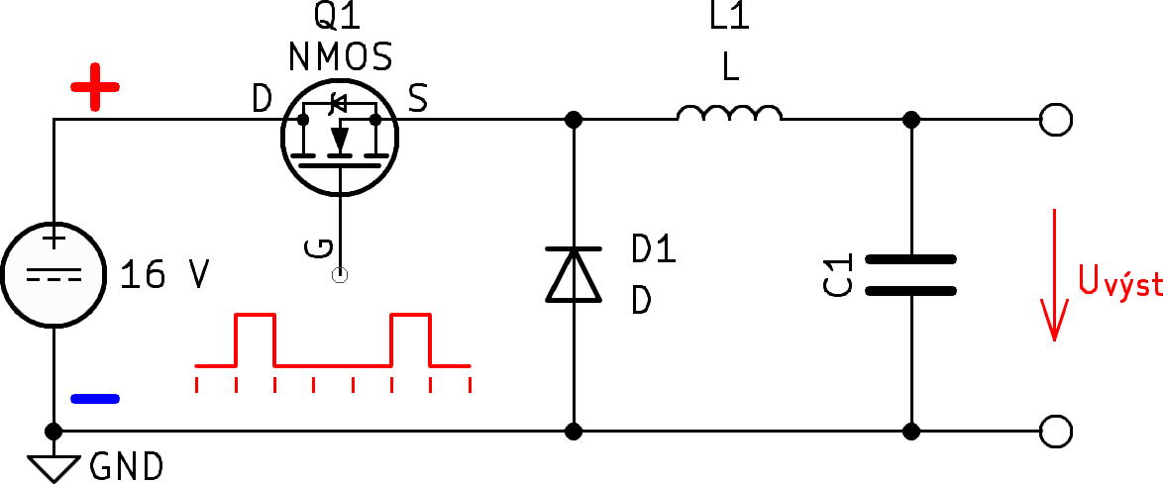

20. What is this converter called?

21. Indicate the polarity of the output voltage in the diagram. What is the value of the output voltage?

**Uvýst =**

22. When communicating with digital peripherals, the so-called SPI bus is very often used. On the left is the control device (microcontroller), on the right is the slave device (AD converter). Draw all the necessary signals for two-way communication,

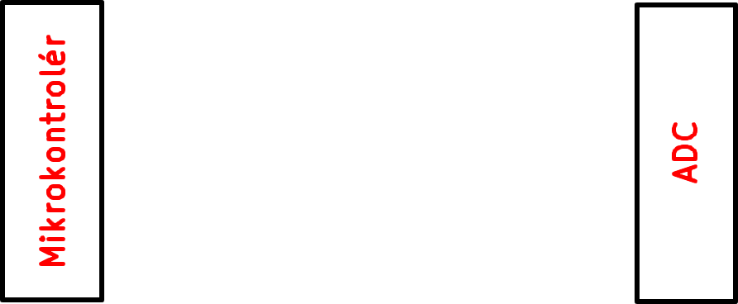

23. Write the truth table of a three-stage NAND gate.

|  |  |  |  |
| --- | --- | --- | --- |
| **A** | **B** | **C** | **Y** |
|  |  |  |  |
|  |  |  |  |
|  |  |  |  |
|  |  |  |  |
|  |  |  |  |
|  |  |  |  |
|  |  |  |  |
|  |  |  |  |

24. The 7-segment display driver converts a 4-bit input code into 7 outputs for each segment. The logic function for segment a is as follows:

𝒂 = 𝑨 + 𝑪 + 𝑩 𝑫 + 𝑩) 𝑫)

implement it using gates

25. We are designing a digital measuring instrument that has a voltage measurement with a resolution of at least 0.01%. What is the minimum number of bits that must be used in the analog-to-digital converter? (consider an ideal converter and subsequent sampling, without using digital signal processing techniques)

# n =



Theoretical part, category A

Page 3 z 4

26. Draw a replacement diagram of a real blood vessel, listing all parasitic features/elements you can think of.

27. In a precision measuring instrument, we need to set the voltage value at terminal C. The first student looked at the diagram and drew a trimmer there

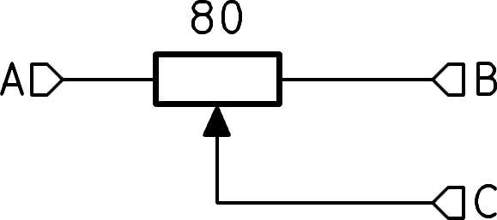

But his colleague tells him that this is not optimal and to design fixed resistors and shorting jumpers:

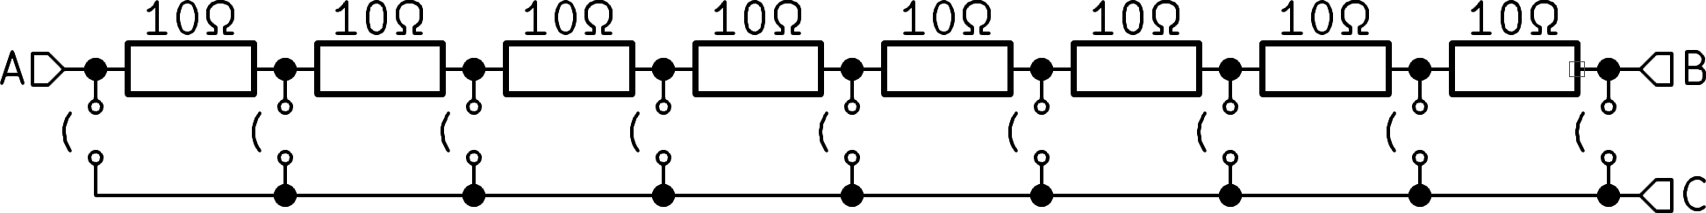

Each of the resistors used is of high quality and costs approx. 10 times as much as the previous trimmer... What important properties for the measuring instrument does the second connection have? Why did he finally use the second design even though it is significantly more expensive? Discuss.

28. Koloman measures the volt-ampere characteristic of a 1N4007 rectifier diode. The diode is connected to a current source and the voltage drop is measured. 0.1 mA, 1 mA, 10 mA, 100 mA are applied successively. The voltage drop increases with increasing current, exactly as I expect. He plots the points on a graph. At the last point of 1 A, the reading is unstable, the tunnel drops sharply. Explain why.

of the same value of 10 kOhm and a tolerance of 1%. What is the maximum deviation of the output voltage with the worst possible combination of tolerances?

**V =**

Will the next 1% resistors be enough, or is it necessary to buy better ones? The standard tolerances available are 5%-2%-1%-0.5%-0.2%-0.1%?

# tol.

30. The most common way to measure with an oscilloscope is to plot time on the x-axis and voltage on the y-axis. In some cases, however, voltage from two different sources is connected to both the x-axis and the y-axis. This produces a picture similar to this:

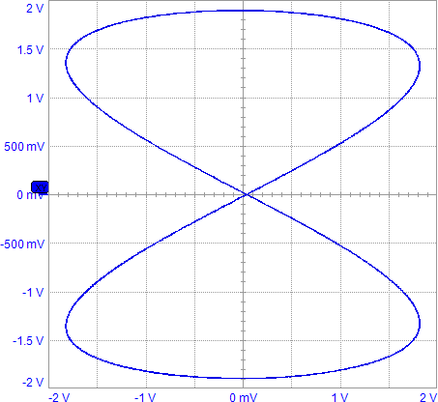

What is this display mode called?

What is it used for?



29. From the reference voltage of 10 V we need tcreate exactly half, 5 V. The maximum tolerance of the output voltage is 30 mV. We use a resistor divider with two resistors

Theoretical part, category A

Page 4 z 4